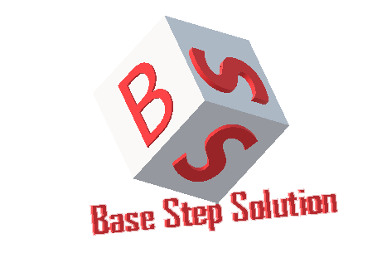

Project Plan

Văn Lang Admissions

# Revision Table

|  |  |  |  |
| --- | --- | --- | --- |
| Author | Date | Reason for changes | Version |
| Tai Nguyen |  | Create Project Plan | 1.0 |

Table of Contents

Revision Table 1

1. INTRODUCTION 3

1.1 GOALS 3

1.2 INTENDED AUDIENCE 3

1.3 TEAM CHARTER 3

2. PROJECT OVERVIEW 3

2.1 PURPOSE 3

2.2 DELIVERIABLE 3

2.3 ROLES AND RESPONSIBILITIES 5

3. HUMAN RESOURCE 5

3.1 PROJECT ORGANIZATION CHART 5

4. PROCESS PROJECT 6

4.1 PROCESS OVERVIEW 6

4.2 EXPLAINING EACH PHASES 7

4.3 PROCESS DECISION 9

5 TECHNICAL 9

6 CONFIGURATION PLAN 9

7 COMMUNICATION PLAN 9

8 CHANGE MANAGEMENT PLAN 9

9 REQUIREMENT PLAN 10

10 ARCHITECTURE DRIVER 10

11 TEST PLAN 10

12 MILESTONE, SCHEDULE 10

12.1 MILESTONE 10

12.2 SCHEDULE 11

# INTRODUCTION

## 1.1 GOALS

This document helps us control our project. We can determine necessary thing for the project such as documents, resource and stakeholder.

## 1.2 INTENDED AUDIENCE

|  |  |
| --- | --- |
| Role | Responsibility |
| All team member | All member on team |
| The mentor | People support group during implement project. |
| Stakeholder on customer side | People give requirement of project |

## TEAM CHARTER

Reference in document:

# PROJECT OVERVIEW

## PURPOSE

This system manage 3,000 new students enrolled each year.

Students, who enrolled to Van Lang, will know all news and be counseled about admissions by mobile devices.

## DELIVERIABLE

|  |  |
| --- | --- |
| Package | Elements |
| Project Planning | Project Plan, Process Decision, Configuration Plan, Measurement plan, WBS, Schedule, Test Plan, Communication Plan, Requirement Plan, Estimation. |
| Requirements | Software Requirement Specification, Concept of Operation, URD, Use-case checklist, Trace ability matrix. |
| Design | Database Design |
| Detail Design |
| Prototype |
| Class Diagram |
| Sequence Diagram |
| Project Monitor and Control | Weekly Report, Team Effort, Meeting minute, team policies, Reflection, Dashboard. |
| Architect | Architecture Drivers, Architecture Design. |
| Implement | Source code, Set-up. |
| Test | Test report, Functional test-case, Quality test-case, Acceptance test-case, Bug defect tracking. |
| Deployment | Install guide, User guide. |

## ROLES AND RESPONSIBILITIES

|  |  |
| --- | --- |
| Role | Responsibility |
| Customer | Persons or organizations that are involved in and influence the project. |
| Project Manager | Person who has overall responsibility for managing the project from the first formal documentation of the project’s initiation to its formal conclusion |
| Project Team | Team responsible for performing project tasks as defined by the project manager. |
| Functional Manager | Person who provides management oversight for administrative work of the project |

# HUMAN RESOURCE

## PROJECT ORGANIZATION CHART

Training Needs

- Code team: Angular 2, Nodejs, Mongodb

- Design team: Design GUI, Sequence Diagram, Class Diagram.

- Test team: Establish Test-case

# PROCESS PROJECT

## PROCESS OVERVIEW

* Used when requirements are well understood
* Iterative in nature; focuses on an operational product with each
* Provides a needed set of functionality sooner while delivering
* Useful also when staffing is too short for a full-scale development
* Generates working software quickly and early during the software
* More flexible – less costly to change scope and requirements.
* Easier to test and debug during a smaller iteration.
* Easier to manage risk because risky pieces are identified and

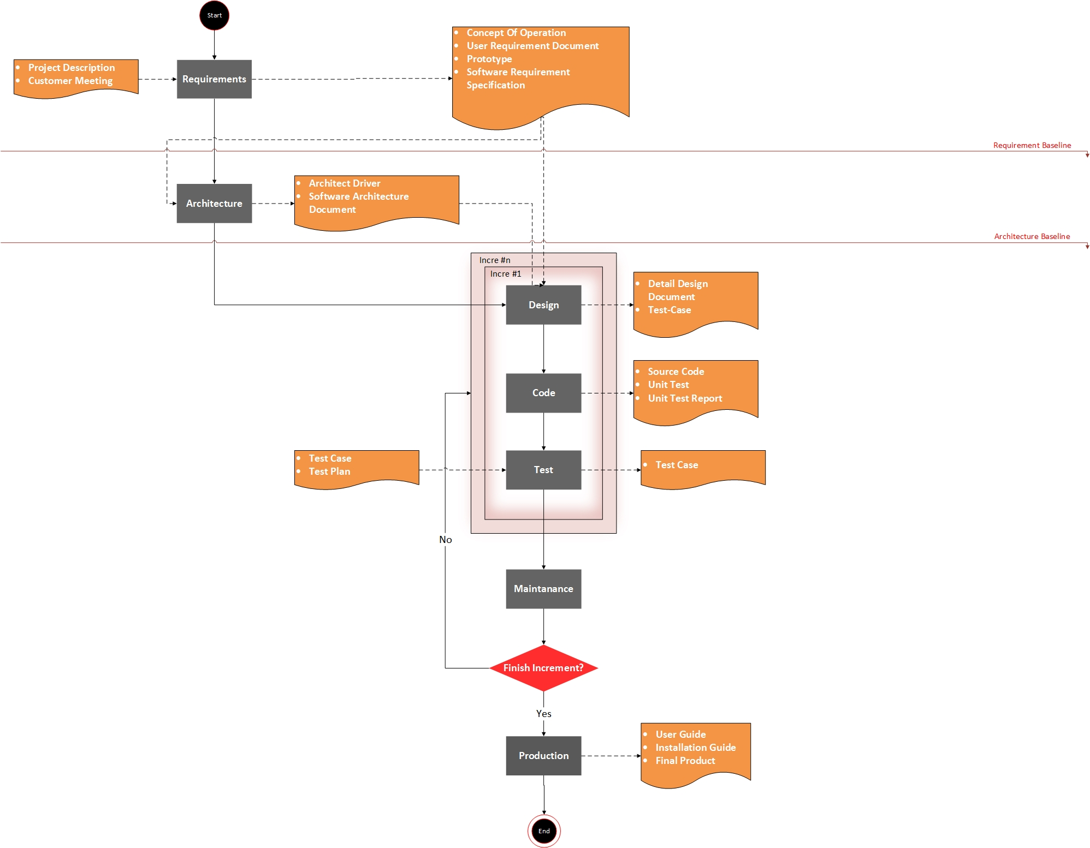

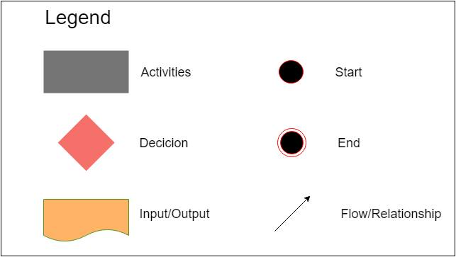

## EXPLAINING EACH PHASES

|  |  |
| --- | --- |
| **Pharse** | **Description** |
| Requirement | * The Customers provide information about business process of them. * All requirements are fully collected through meetings with customers then analyze and asked, confirm with the customer. * These requests will be evaluated to choose important requirements, so we can arrange priority of requirement. |
| Architecture | The requirements of customers are divided and grouped into sections (modules) each functionality to manage the conduct of software development easily.  Hardware and software are agreed after discussions with customer in meetings.  Analyze quality attribute and trade-off with the customer to bring best thing for customer and team project. |
| Design | Training Design member  Make use case description, use-case diagram, sequence diagram, database.  Determine all functions, quality attribute |
| Implement | Training Implement member  Programming all interface and function for the program. |
| Test | Training Test member  write document: System test, Acceptance test, Summary report, Test case, Bugs List  Run test case |
| Maintain | Guide customer how to use and install program |

## PROCESS DECISION

Reference: BSS_ProcessDecision_Ver1.2

# TECHNICAL

* Microsoft Office 2013: Word, Excel, Power Point.
* Rational Rose 2003.
* Webstorm.
* Visio

# CONFIGURATION PLAN

Reference in document: BSS_ConfigurationManagementPlan_V2.0

# COMMUNICATION PLAN

Reference in document: BSS_CommunicationManagementPlan_V1.0

# CHANGE MANAGEMENT PLAN

Reference in document: BSS_ChangeManagementPlan_V2.0

# REQUIREMENT PLAN

Reference in document: BSS_SoftwareRequirementProcess_v2.0

# ARCHITECTURE DRIVER

Reference in document: BSS_SoftwareArchitecturalProcess_v1.1

# TEST PLAN

Reference in document: BSS_TestPlan_v1.4

# MILESTONE, SCHEDULE

## MILESTONE

|  |  |  |
| --- | --- | --- |
| **Phase** | **Start day** | **End day** |
| Kick-Off | 03/10/2016 | 14/10/2016 |
| Planning | 17/10/2016 | 4/11/2016 |
| Requirement | 7/11/2016 | 10/12/2016 |
| Architecture | 12/12/2016 | 27/12/2016 |
| Release 1 | 2/01/2017 | 25/02/2017 |
| Release 2 | 27/02/2017 | 25/03/2017 |
| Release 3 | 27/3/2017 | 22/4/2017 |
| Closure | 24/4/2017 | 28/5/2017 |



## SCHEDULE

Reference: BSS_Schedule_V1.0